Muyassar Kokhkharova

Effort: 2 hours

**Change label colors in GUI**

In mainController we set a reference to mainController so that the FallNotificationService can change the color of labels.

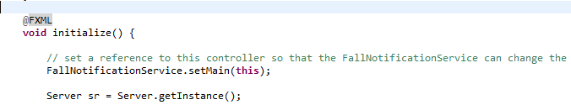

In FallNotificationService in method waitForFall() after fall happens color of “Fall Detected” label changes from black to red.

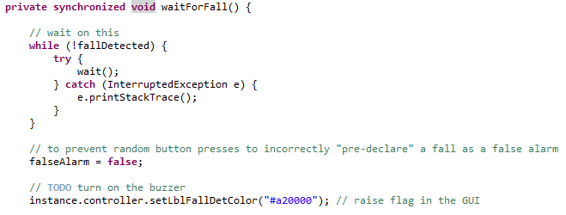

Then if False Alarm happens color of “Help Requested” label remains black, else changes to red

